NEPAL COLLEGE OF INFORMATION TECHNOLOGY
Balkumari, Lalitpur
Affiliated to Pokhara University

LAB REPORT FOR EMBEDDED SYSTEMS


LAB REPORT 3: UNIVERSAL GATES AND SPECIAL GATES

Submitted by: Submitted to:
Name: Arpan Adhikari Er. Simanta Kasaju Roll No.: 231309
BE-CE (5th SEM)

S. N | LAB TOPIC | DATE | REMARKS
1. | VHDL Code (OR & AND Gate) | 20th Nov
2. | VHDL Code (OR & NOT Gate) using testbench | 23rd Nov
3. | Universal Gates and Special Gates | 30th Nov

LAB 3: UNIVERSAL GATES AND SPECIAL GATES

OBJECTIVE:
- To study and understand the working principles of universal gates (NAND and NOR).
- To verify that NAND and NOR gates can perform the operations of basic logic gates.
- To write and simulate VHDL code for universal gates.
- To study the working of special gates using VHDL.
- To observe the simulation waveforms and verify truth table outputs.
THEORY:

Universal Gates (NAND & NOR)
Universal gates are logic gates that can be used to construct any Boolean function or digital logic circuit. The two universal gates are NAND and NOR.

NAND Gate
The NAND gate is an AND gate followed by a NOT gate.
- The output is LOW only when both inputs are HIGH.
A | B | NAND
0 | 0 | 1
0 | 1 | 1
1 | 0 | 1
1 | 1 | 0
A NAND gate can be used to construct all basic gates (NOT, AND, OR), making it universal.

NOR Gate
The NOR gate is an OR gate followed by a NOT gate.
- The output is HIGH only when both inputs are LOW.
A | B | NOR
0 | 0 | 1
0 | 1 | 0
1 | 0 | 0
1 | 1 | 0
A NOR gate can also produce all basic gates, and therefore it is also universal.

Special Gates
Special gates are advanced logic gates used for specific logical operations. Common special gates include:
- XOR (Exclusive OR) – Outputs 1 if inputs are different.
- XNOR (Exclusive NOR) – Outputs 1 if inputs are the same.
- Buffer – Passes input directly to output.
These gates are widely used in arithmetic circuits, comparators, parity checkers, and digital
VHDL CODE FOR UNIVERSAL GATES:

library IEEE;
use IEEE.Std_Logic_1164.all;

Entity Gate is
port(
A, B : in Std_Logic;
nandop, norop : out Std_Logic
);
end Gate;
-- nandop and norop is output for NAND and NOR respectively

architecture archGate of Gate is
begin
process(A,B)
begin
if ( A = '1' and B = '1') then
nandop <= '0';
else
nandop <= '1';
end if;

if ( A = '0' and B = '0') then
norop <= '1';
else
norop <= '0';
end if;
end process;
end archGate;

TEST BENCH FOR UNIVERSAL GATES:

library IEEE;
use IEEE.Std_logic_1164.all;

Entity test_gates is
end test_gates;

Architecture arpangatebehavioral of test_gates is
component arpangate
port(
A, B : in Std_Logic;
nandop, norop : out Std_Logic
);
end component;

Signal A,B : Std_logic := '0';
Signal nandop, norop : Std_Logic;

begin
UUT: arpangate port map
(
A => A,
B => B,
nandop => nandop,
norop => norop
);

stim_proc: process
begin
A<='0'; B<='0';
wait for 100 ns;
A<='0'; B<='1';
wait for 100 ns;
A<='1'; B<='0';
wait for 100 ns;
A<='1'; B<='1';
wait for 100 ns;
end process;
end arpangatebehavioral;

Waveform for Universal Gates:

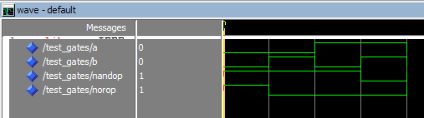

VHDL CODE FOR SPECIAL GATES:

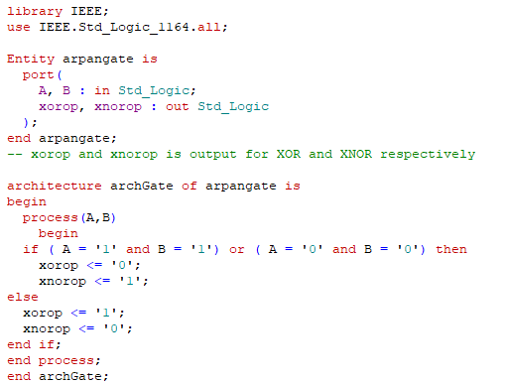

TEST BENCH FOR SPECIAL GATES:

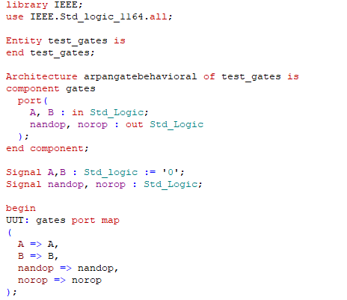

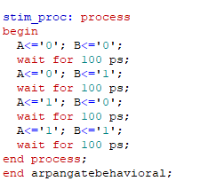

Waveform for Special Gates:

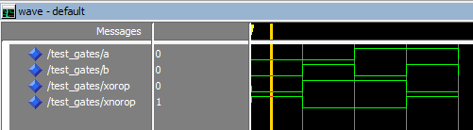

RESULT:
- VHDL codes for NAND, NOR, and special gates were successfully written and simulated.
- The output waveforms obtained from simulation matched the theoretical truth tables.
- The test benches correctly generated all required input combinations.
- Both universal gates and special gates worked as expected during simulation.

CONCLUSION:
The experiment verified that NAND and NOR gates are truly universal gates, as they can implement any logical function.
The VHDL simulations confirmed the theoretical truth tables for NAND, NOR, XOR, XNOR, and other special gates.
This practical demonstrated how VHDL can be used effectively to design, simulate, and test digital logic circuits before hardware implementation.

